IN-LINE SPARGING APPLICATION DATA SHEET (SADS)

**Please complete all applicable fields associated with your application for best recommendation**

COMPANY NAME |  | CONTACT NAME
ADDRESS |  | TITLE
 |  | EMAIL
DATE |  | PHONE

**Choose Application Type From This Drop Down

DETAILED SUMMARY OF PROCESS DESCRIPTION AND OBJECTIVES
LIQUID INFORMATION |  | GAS INFORMATION
**NAME of LIQUID |  | ** NAME of GAS
VISCOSITY (cP) |  | VISCOSITY (cP)
DENSITY (LB/IN3) |  | **GAS FLOW RATE (SCFM)  If gas flow rate is unknown, provide detailed application parameters
**PRESSURE (PSIG) |  | **PRESSURE (PSIG)
**TEMPERATURE (DEG F) |  | TEMPERATURE (DEG F)
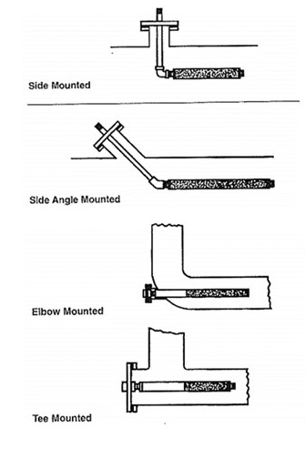

PIPELINE INSTALLATION
INSTALLATION TYPE (select one) | Choose an item.
**PIPE SIZE
**LIQUID FLOW RATE (GPM)

SPARGER MOUNTING CONNECTIONS
PROCESS CONNECTION TYPE / SIZE
GAS CONNECTION TYPE / SIZE

SPECIAL FINISH REQUIREMENTS: SPECIFY
- Please provide applicable drawings if available.
- If different units apply, please annotate as such.

Porous Material | 316L SS | Other
Hardware | 316/316L SS | Other

